**Experiment No.: 4 Date: 07-03-2023**

**AIM**: Familiarization of linux commands.

**CO2**: Perform system administration task.

**Procedure:**

1. Cut command - to cut char

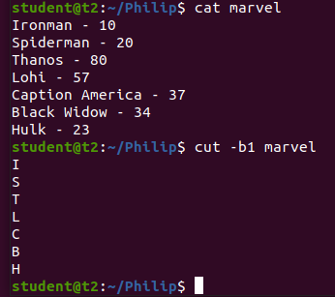

1.1 cut - c :cut letters from a file

$cut -c 1,2,4, marvel

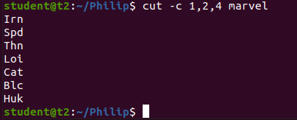

2. paste contents of one file to other

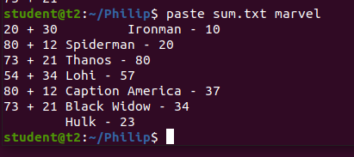

2.1 paste contents of two files into a third file

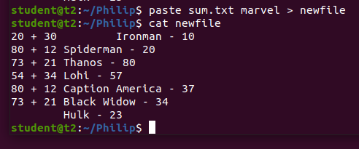

2.2 append using paste command

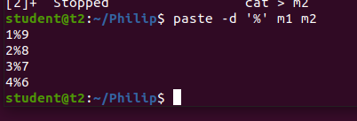

**Result**

The program was executed and the result was successfully obtained. Thus CO2 was obtained